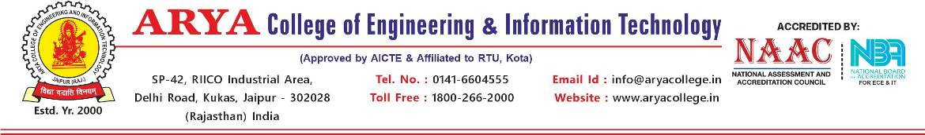
CSE Project Progress Report
Mentor Name:- DR. VISHAL SHRIVASTAVA Date:- 18.08.2025
Project Name:- PRIHUB – SUPPORT FOR COGNITIVE DISABILITIES

Student ID | Student Name | Signature
1. 22EARCS125 | 1. PRANJAL KHANDELWAL | 1.  
2. 22EARCS082 | 2. KETAN CHOWDHURY | 2. Ketan
3. 22EARCS121 | 3. PELHEIBA KHANGEMBAM | 3. Pelheiba
4. 22EARCS185 | 4. VISHAKHA TOMAR | 4. Vishakha
Weekly Progress Report
Monday
Our team members met together and discussed the project topic “PriHub – Support for Cognitive Disabilities”. Roles were divided among us (leader, documentation, survey, technical).
Tuesday
We carefully read through the DST project guidelines and our submitted proposal to make sure we understood what is expected.
Wednesday
We listed the people who will be important for this project, such as doctors, therapists, NGOs, teachers, and students with special needs.
Thursday
The team discussed the common issues faced by people with cognitive disabilities while using normal websites (like small text, too much content, or lack of voice support).
Friday
Together we drafted the first set of project goals, like making a user-friendly, accessible, and supportive platform.
Saturday
We met our mentor, presented these initial goals, and got suggestions to refine them further.

Mentor Signature…………………………….

